Adenosine receptor antagonists for prevention of acute kidney injury post neonatal perinatal asphyxia: a systematic review and meta-analysis
Liu Taixiang
Department of NICU, the Children’s Hospital, Zhejiang University School of Medicine,
National Clinical Research Center For Child Health

ABSTRACT
Objective To evaluate the effect of adenosine receptor antagonists for prevention of acute kidney injury (AKI) in neonates with severe birth asphyxia.
Methods We searched in the Cochrane Central Register of Controlled Trials (CENTRAL), MEDLINE/PubMed, EMBASE,abstracts of the major pediatric society meetings,reference list of published trails and review articles.We included randomized and quasi-randomised controlled trials assessing the effects of adenosine receptor antagonists therapy on AKI in neonates with severe perinatal asphyxia.A random/fixed-effect model was used to synthesize predefined outcomes.
Results Nine studies involving 495 neonates with birth asphyxia were included in the qualitative synthesis and meta-analysis.The pooled estimate showed 59% reduction in the incidence of AKI in the neonates with severe birth asphyxia receiving a single doses of prophylactic adenosine receptor antagonists compared with placebo (RR: 0.41; 95% CI 0.31 to 0.54; I²=0%),the subgroup analysis showed that theophylline (RR: 0.40; 95% CI 0.30 to 0.54; I²=0%) was better than aminophylline(RR: 0.52; 95% CI 0.18 to 1.52; I²=0%) compared with placebo in reducing the morbidity of AKI,and 8 mg/kg theophylline (RR: 0.37; 95% CI 0.22 to 0.62; I²=0%) had the best effect on reducing the incidence of AKI in another subgroup analysis.The pooled estimated showed 14% reduction of mortality and a significant decrease in serum creatinine levels in neonates who received prophylactic adenosine receptor antagonists.However,the difference between the two groups as well as the sungroup analysis were not significant in mortality.The only trial on aminophylline (RR: 0.67; 95% CI 0.12 to 3.65) showed 33% reduction of mortality. A significant difference in the negative fluid balance, increase in glomerular filtration rate (GFR) and urinary creatinine levels,decrease in urinary β2 microglobulin was seen in favour of adenosine receptor antagonists.
Conclusion A single dose of prophylactic adenosine receptor antagonists helps in prevention of AKI in neonates with severe birth asphyxia without affecting mortality.

INTRODUCTION
The term birth asphyxia can be defined as a condition of impaired gas exchange in the neonates during the perinatal period, which leads to progressive hypoxia, hypercarbia, and acidosis depending on the extent and duration of this interruption1, occurring in up to 72% of these infants2. There is no internationally acceptable deﬁnition of acute kidney injury (AKI) in the neonates, making estimations of its incidence and studies of its management difﬁcult. Most researchers have defined AKI in neonates by biochemical indicators such as serum/urinary creatinine, urine volume, glomerular filtration rate (GFR) and β2-microglobulin (β2M)3-5.
During perinatal asphyxia, hypoxia or ischemia can activate adenosine receptors in renal tubules and endothelial cells, which improved ischemia-reperfusion injury by regulating metabolic demand, reducing necrosis, apoptosis and inflammation6. Some of the previous studies and randomised controlled trials(RCTs) have shown the benefit of adenosine receptor antagonists such as theophylline and aminophyllinein in reducing the AKI caused by perinatal hypoxic-ischemic insult in recent years7-13. Al-Wassia H and Bhatt GC had conducted two meta-analyses successively to evaluate the effect of theophylline and aminophylline for prevention of AKI in neonates and children14-15 . Since then, one RCT has been published in 2020 and a conference paper was found by manual search16,17, moreover, the two meta-analyses did not compare the effects of different doses or types of adenosine receptor antagonists on outcome indicators. Thus, we conducted this updated systematic review including RCTs and quasi-randomised trials to explore the present evidence for the use of adenosine areceptor ntagonists for prevention of AKI after asphyxia.

METHODS
Search strategy
We included randomized or quasi-randomized controlled trials evaluating either theophylline or aminophylline compared with placebo for prevention of AKI in neonates with perinatal asphyxia.
We will conduct a comprehensive search in the Cochrane Central Register of Controlled Trials (CENTRAL), MEDLINE/PubMed, EMBASE using following search terms:
((((((adenosine antagonist) OR theophylline) OR aminophylline) OR caffeine)) AND ((((acute kidney injury) OR acute renal injury) OR acute renal failure) OR acute renal insufficiency)) AND (asphyxia ) OR ( perinatal asphyxia) AND (((neonates) OR newborn infants) OR infants)
Restrictions: "Human" AND "English language restrictions"
In addition, we will hand search reference list of published trails and review articles.
Exclusion inclusion criteria
Types of participants neonates with severe asphyxia who received a single dose of theophylline or aminophylline intravenously during the first hour after birth for prevention of AKI and compared with standard therapy or placebo were eligible. Exclusion criterion were: small for gestational age (SGA), kidney ureter bladder (KUB) anomaly, polycythemia, chromosomal disorders, history of tachyarrhythmias, seizures, and drug intake by mother causing depression, parent of subject did not agreed or quit to study. The definition of AKI was taken as used in the individual study.
Main outcomes:
To evaluate the incidence and mortality of AKI.
Secondary outcomes:
To evaluate balance of water output and input, renal tubular and glomerular function, including urine β-2M, GFR and serum/urinary creatinine levels in initial 5 days of life.
Data extraction (selection and coding)
A systematic search will be conducted using keywords, MESH terms and free-text terms to identify studies. Identification will be independently undertaken by at least 2 reviewers. Data will be extracted to pre-specified data-collection form, before pooling for analysis.
Assessment of trial quality
Two reviewers independently assessed the quality of individual studies by using Cochrane methodological quality assessment forms18. Any disagreements were resolved by discussion and consensus. The methodological quality of the studies was assessed using the following key criteria: method of randomization, allocation concealment, blinding of intervention, blinding of outcome and whether all outcomes of all infants enrolled in the trial were reported. For each criterion, assessment was yes, no or not described.
Strategy for data synthesis
The data will be pooled and expressed as mean difference (MD) with 95% confidence interval (CI) in case of continuous data and risk ratio (RR) with 95% CI in case of categorical data. P-value < 0.05 will be considered significant. I-squared statistics will be used for assessment of heterogeneity. If there is a high level heterogeneity (>50%), the authors will try to explore the cause. A fixed effects model will be initially conducted. If significant heterogeneity exists between trials, potential sources of heterogeneity will be considered and where appropriate a random effects model will be used. RevMan (Review Manager) version 5 will be used for all the analyses.
Assessment of heterogeneity
We will assess heterogeneity between trials by inspecting the forest plots and quantifying the impact of heterogeneity using the I2 statistic, using the following categories as defined by the Cochrane Neonatal Review Group: less than 25%: no heterogeneity; 25% to 49%: low heterogeneity; 50% to 74%: moderate heterogeneity; 75% or greater: high heterogeneity.
We will explore possible causes of statistical heterogeneity using pre-specified subgroup analysis (e.g. differences in intervention regimens).
Assessment of reporting biases
We did not plan to assess publication bias using the funnel plot for fewer than 10 studies were included in the meta-analysis.
Analysis of subgroups or subsets
Planned subgroup analyses will be performed if substantial heterogeneity is noted.
- Theophylline and aminophylline group;
- Be divided into groups on the basis of different drug doses.

RESULT
A total of 495 citations were retrieved by using the search strategy. Nine studies7-13 met inclusion criteria and were included in the meta-analysis. Figure 1 shows the flow diagram of studies identified in the PRISMA format. Nine trials, including 548 participants, evaluated the effect of prophylactic adenosine receptor antagonists for the prevention of AKI in neonates with severe birth asphyxia.
The characteristics of the included study are shown in table 1. Six studies7,9-13 compared theophylline (a single doses of 5mg/kg in four trials9,10,12,13 and 8mg/kg in two trials7,11) with placebo. The remaining three studies8,16,17 compared aminophyllinein (a single doses of 5mg/kg) with placebo, one of the trials was in preterm neonates with birth asphyxia8. Table 2 shows the comparison of the study quality. Three studies7,12,16 were of high quality satisfying ≥ 4 out of 7 criteria, and the remaining studies were of either low or unclear quality8-11,13,17.

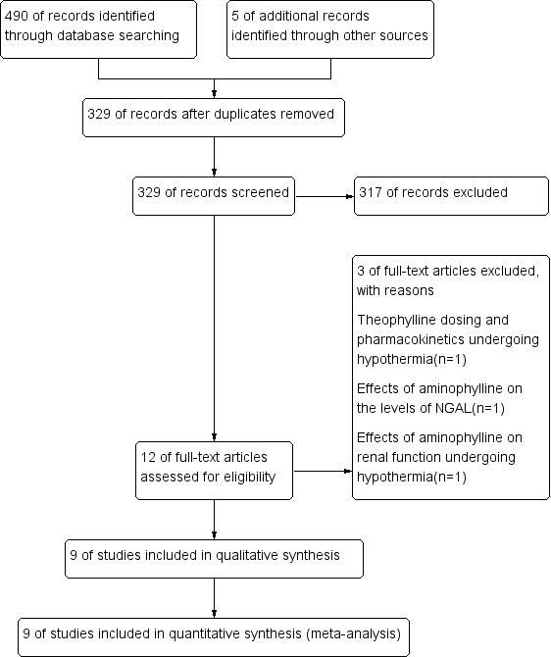
Figure 1. Flow diagram for selection of studies.
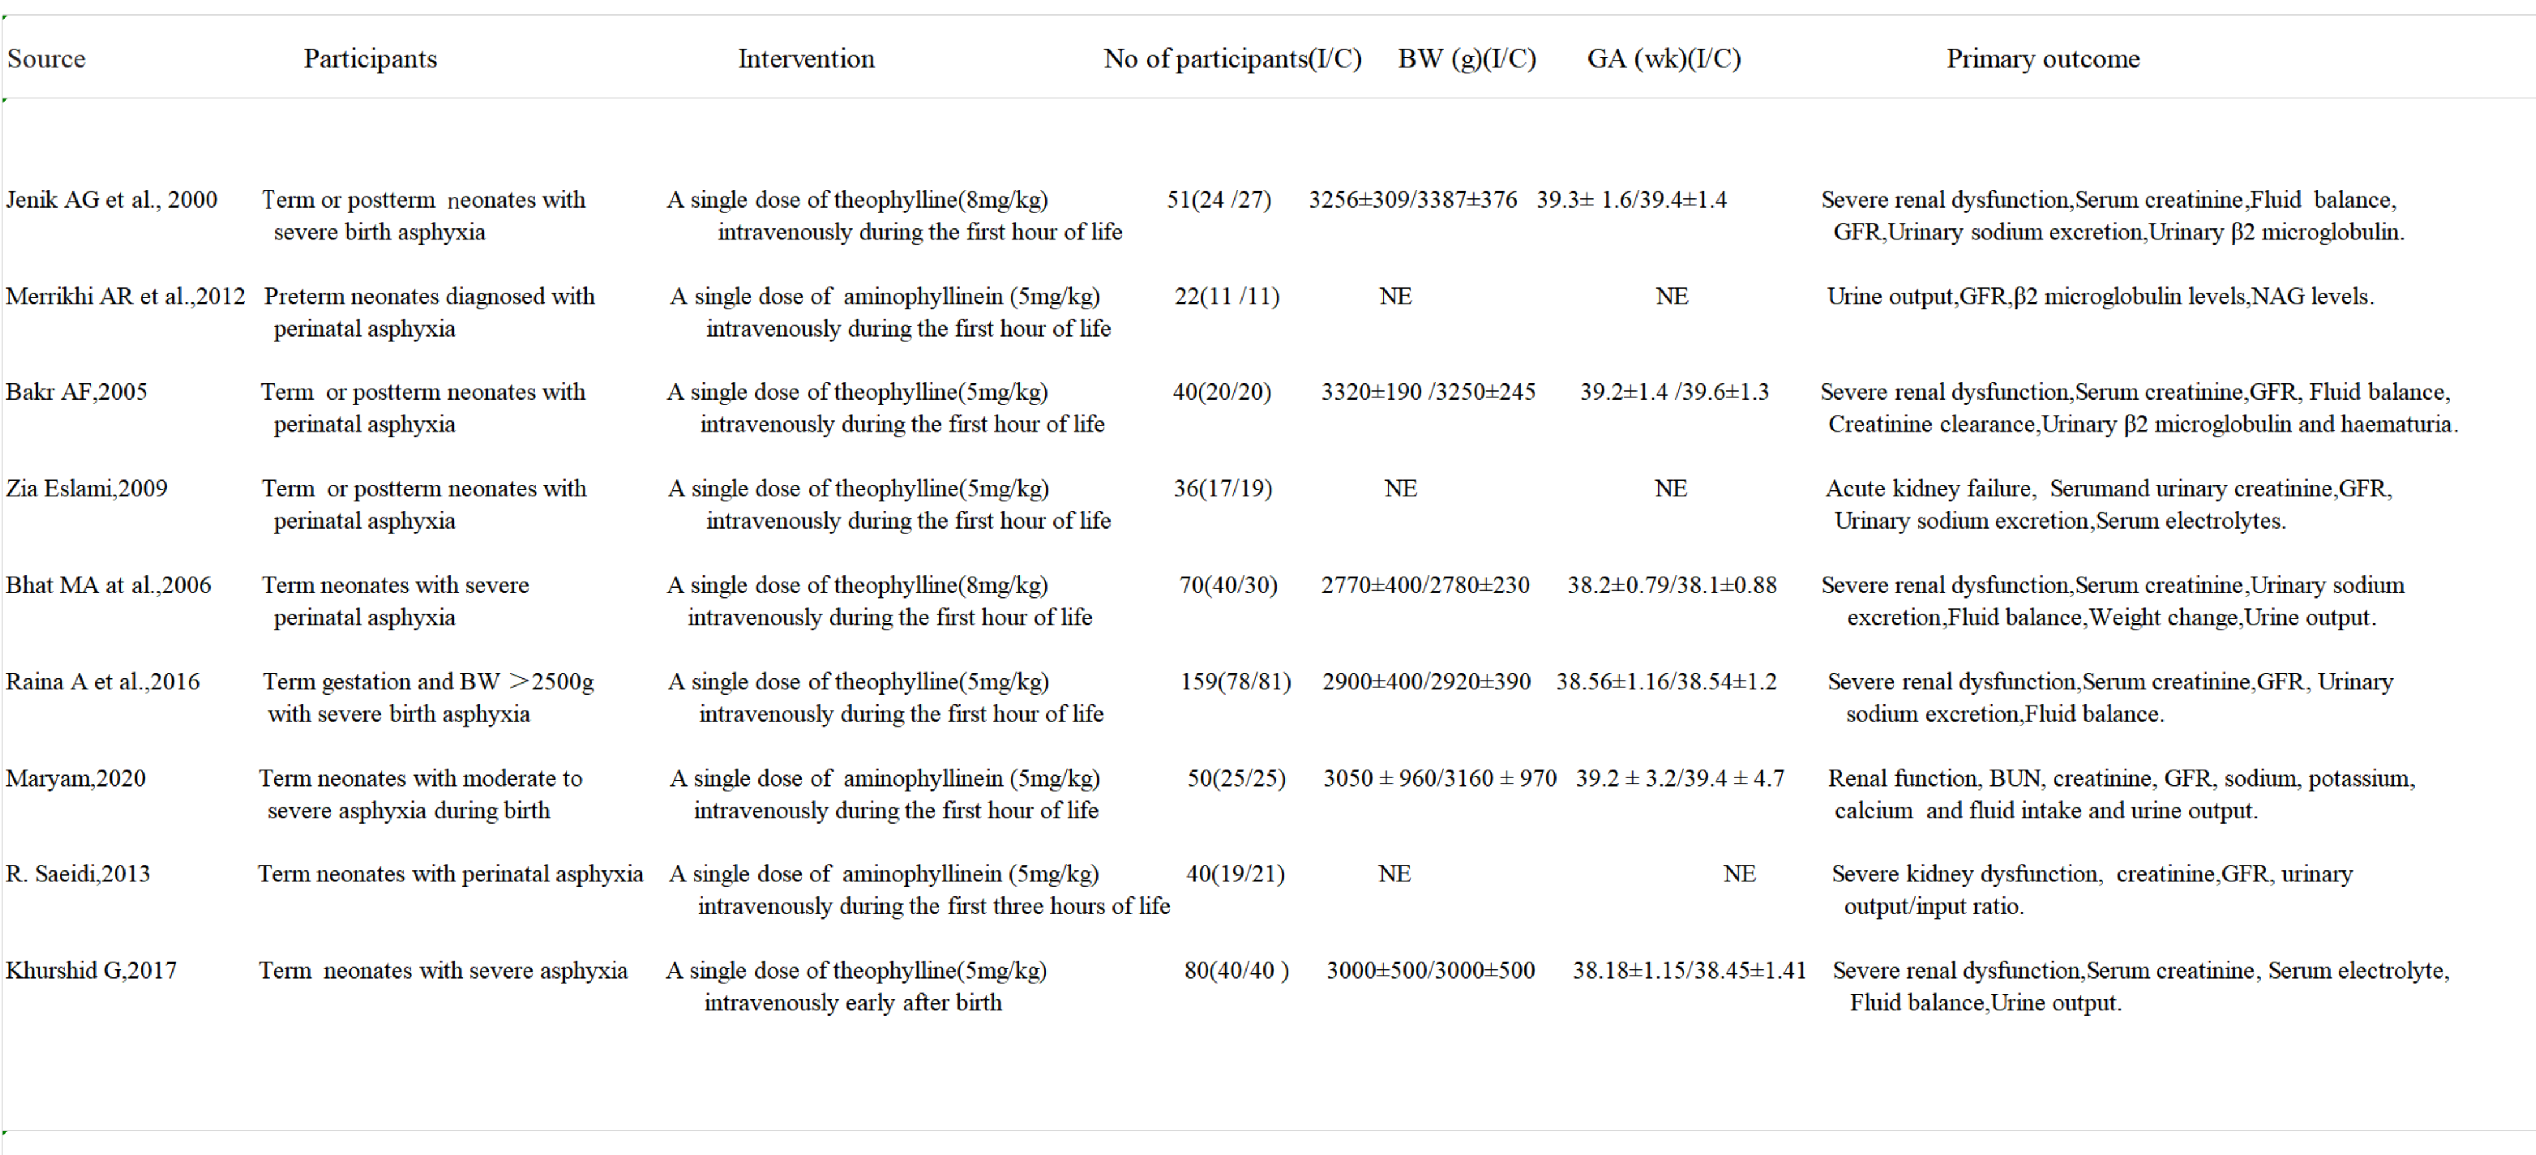
Table 1. Characteristics of the trials included in the analysis.

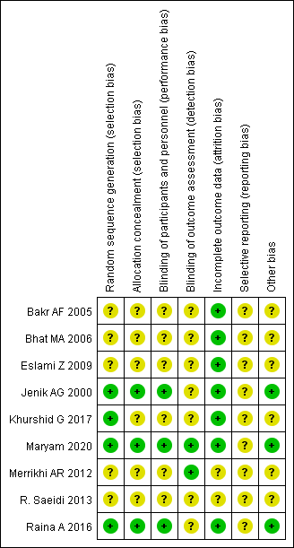
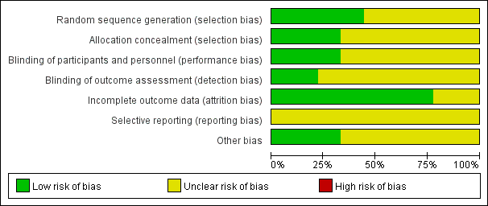

Table 2.Risk of bias summary and risk of bias graph: review authors' judgements about each risk of bias item presented as percentages across all included studies.

Primary outcomes
Incidence of AKI
eight trials7-13,17, with 498 participants reported this outcome. The pooled estimate showed 59% reduction in the incidence of AKI in the neonates with severe birth asphyxia receiving a single doses of prophylactic adenosine receptor antagonists compared with placebo (RR: 0.41; 95% CI 0.31 to 0.54; I²=0%) (figure 2). Of the eight studies, six 7,9-13were theophylline and two8,17 were aminophylline. We performed a subgroup analysis of different sorts of adenosine receptor antagonists and the result showed that theophylline (RR: 0.40; 95% CI 0.30 to 0.54; I²=0%) was better than aminophylline (RR: 0.52; 95% CI 0.18 to 1.52; I²=0%) compared with placebo in reducing the incidence of AKI (figure 3). Another subgroup analysis was conducted to compare the effects of single doses of 8 mg/kg theophylline (RR: 0.37; 95% CI 0.22 to 0.62; I²=0%), 5 mg/kg theophylline (RR: 0.42; 95% CI 0.29 to 0.59; I²=20%) and 5 mg/kg aminophylline (RR: 0.52; 95% CI 0.18 to 1.52; I²=0%) with placebo on the incidence of AKI(figure 4). The results showed that the 8 mg/kg theophylline was the best, followed by 5 mg/kg theophylline, and 5mg/kg aminophylline was the lowest.
Mortality in neonates
six trials7,9-12,16 with 428 participants reported 52 deaths. The pooled estimated showed 14% reduction of mortality in neonates who received prophylactic adenosine receptor antagonists. However, the difference between the two groups was not significant (RR: 0.88; 95% CI 0.52 to 1.42; I2=0%) (figure 5). We also performed a subgroup analysis compared the effects of a single doses of 8 mg/kg theophylline, 5 mg/kg theophylline and 5 mg/kg aminophylline with placebo on the mortality and found that theophylline of 8 mg/kg (RR: 0.88; 95% CI 0.25 to 3.03; I²=0%) and 5 mg/ kg (RR: 0.88; 95% CI 0.49 to 1.58; I²=0%) reduced mortality by 12%, but no significant difference was found (figure 6). The only trial on aminophylline (RR: 0.67; 95% CI 0.12 to 3.65) showed 33% reduction of mortality.
Secondary outcomes
- eGFR during the initial 5 days: six trials7-10,12,16 reported this outcome. Although there was no significant difference in the eGFR on days 1 (MD: 1.54; 95% CI −0.8 to 3.87; I2=22%) and 4 (MD: 6.29; 95% CI −7.02 to 19.6; I2=93%), the difference was significant on days 2 (MD: 9.4; 95% CI 6.15 to 12.65;I2=0%), 3 (MD: 12.65; 95% CI 10.20 to 15.09; I2=21%) and 5 (MD: 10.07; 95% CI 5.81 to 14.33; I2=48%)(figure 7).
- Urinary β2 microglobulin levels during the initial 5 days: three trials7,8,11 reported this outcome.The pooled results showed significantly lower mean urine β2 microglobulin (β2M) concentrations, used as a marker of tubular injury in the treatment group compared with the control (MD: −7.07; 95% CI −8.93 to –5.22; I2=32%) (figure 8).
- Creatinine levels during the initial 5 days: this outcome was reported by seven trials7,9-13,16. A high degree of unexplained heterogeneity was noted for this outcome. There was no significant difference between the creatinine levels on day 1 (mean difference (MD): −0.20; 95% CI −0.58 to 0.18; I2=99%). Over the next 2-5 days, there was a significant decrease in serum creatinine levels in neonates who received adenosine receptor antagonists(figure 9).
- Urinary creatinine levels during the initial 5 days:Two trials10,12 reported this outcome.There was significant difference between the two groups on day 1 (MD: 4.23, 95% CI 0.27 to 8.19; I2=0%),day 3 (MD: 20.82; 95% CI 7.77 to 33.87; I2=92%) and day 5 (MD: 12.24; 95% CI 4.05 to 20.42; I2=73%)(Figure 10).
- Water output/input ratio during the initial 5 days: three trials7,9,11 reported this outcome,and the pooled estimate showed a significant negative fluid balance in the neonates who received a single dose of prophylactic adenosine receptor antagonists as compared with placebo. There was no significant difference between the two groups on day 1 (MD: −0.22, 95% CI −0.51 to 0.08; I2=95%),day 2 (MD: 0.79; 95% CI 0.05 to 1.53; I2=96%) and day 4 (MD: 0.20; 95% CI −0.22 to 0.62; I2=89%). However, the difference was significant on day 3 (MD: 0.5; 95% CI 0.11 to 0.89;I2=86%) and day 5 (MD: 0.32; 95% CI 0.20 to 0.44; I2=33%)(figure 11).

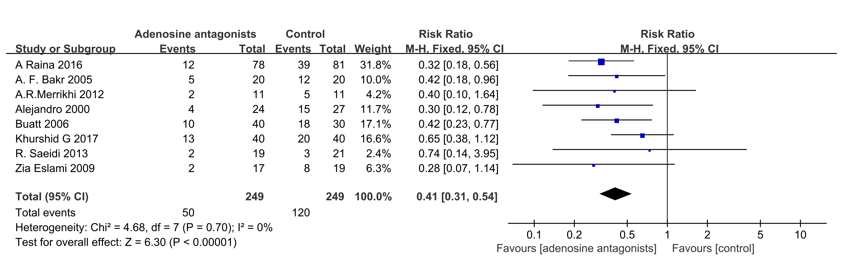Figure 2. Forest plot of comparison: adenosine receptor antagonists (theophylline and aminophyllinein) vs placebo, Outcome:the incidence of AKI

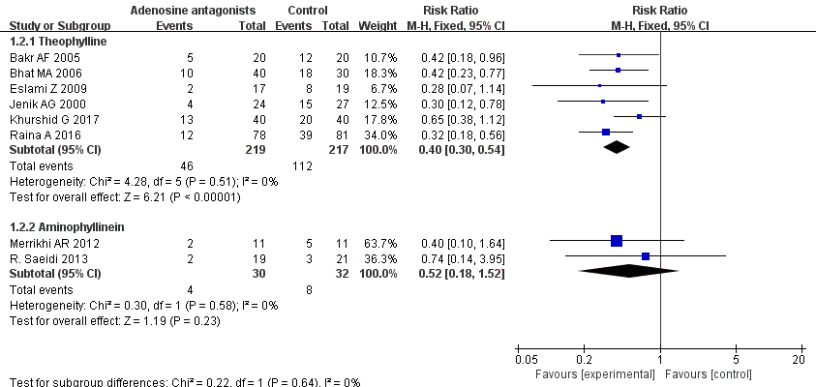
Figure 3. Forest plot of adenosine receptor antagonists subgroup analysis: theophylline group vs placebo and aminophyllinein group vs placebo, Outcome:the incidence of AKI.

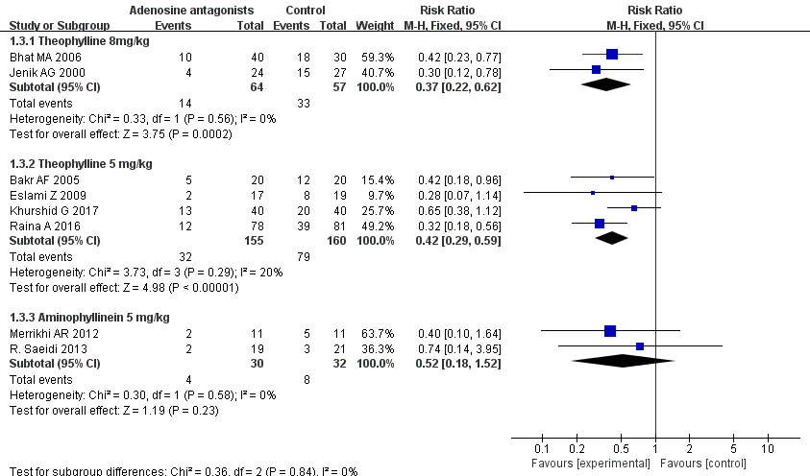
Figure 4. Forest plot of adenosine receptor antagonists subgroup analysis: theophylline(8mg/kg) group, theophylline(5mg/kg) group and aminophyllinein(5mg/kg) group vs placebo, Outcome:the incidence of AKI.

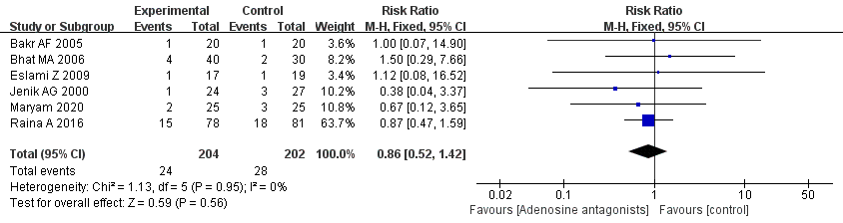
Figure 5. Forest plot of comparison: adenosine receptor antagonists (theophylline and aminophyllinein) vs placebo, Outcome:the mortality of AKI.

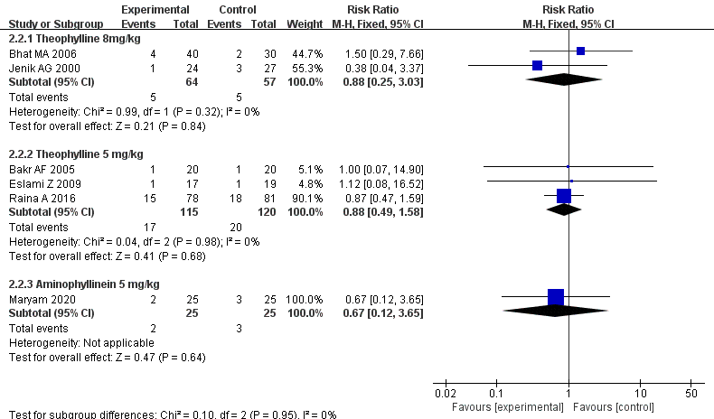
Figure 6. Forest plot of adenosine receptor antagonists subgroup analysis: theophylline(8mg/kg) group, theophylline(5mg/kg) group and aminophyllinein(5mg/kg) group vs placebo, Outcome:the mortality of AKI.

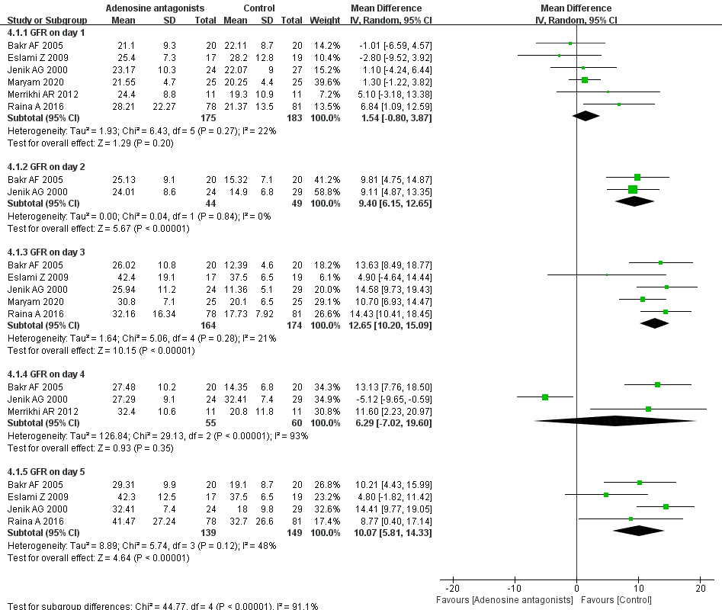
Figure 7. Forest plot of comparison: adenosine receptor antagonists (theophylline and aminophyllinein) vs placebo, Outcome:eGFR during the first 5 days.

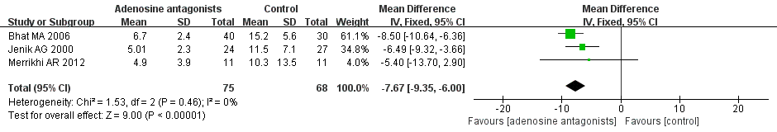
Figure 8. Forest plot of comparison: adenosine receptor antagonists (theophylline and aminophyllinein) vs placebo, Outcome:urine β2 microglobulin (β2M) concentrations.

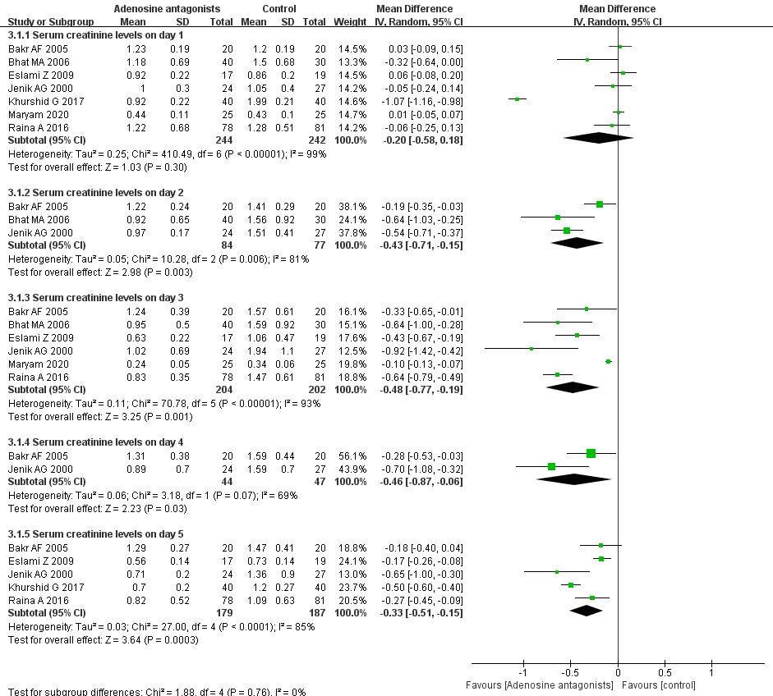
Figure 9. Forest plot of comparison: adenosine receptor antagonists (theophylline and aminophyllinein) vs placebo, Outcome:serum creatinine levels during the first 5 days.

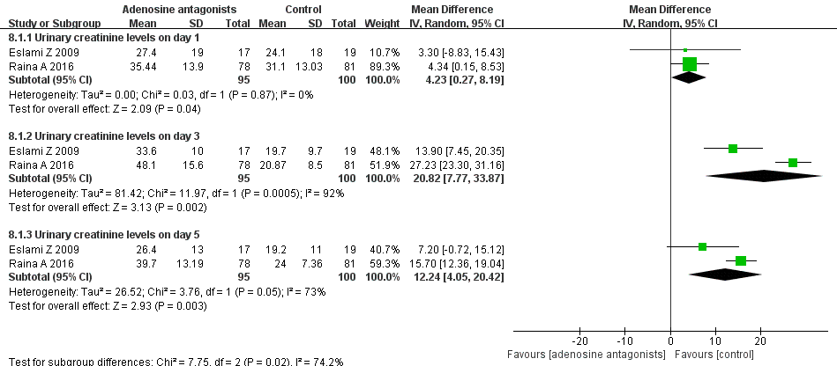
Figure 10. Forest plot of comparison: adenosine receptor antagonists (theophylline and aminophyllinein) vs placebo, Outcome:urinary creatinine levels during the first 5 days.

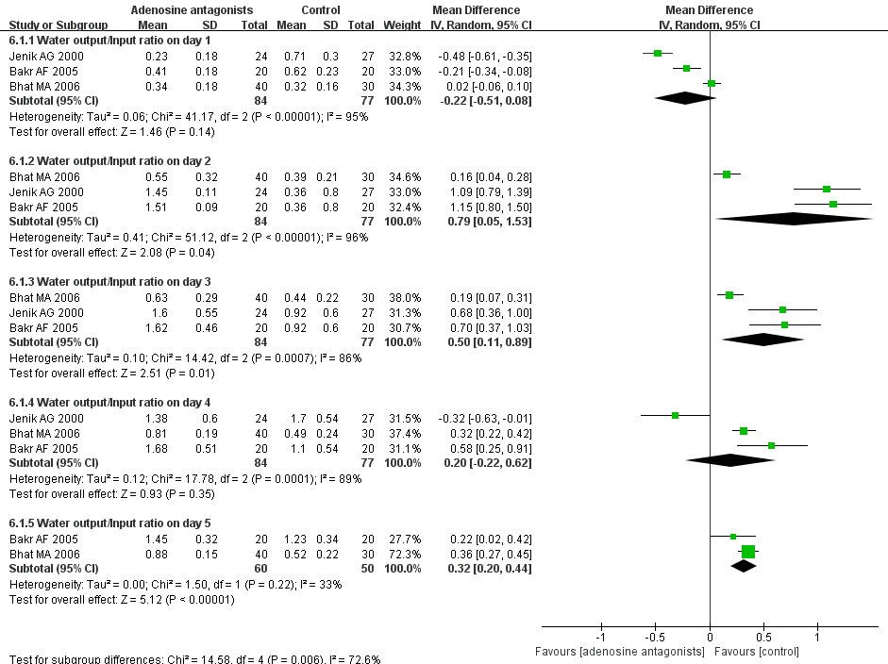
Figure 11. Forest plot of comparison: adenosine receptor antagonists (theophylline and aminophyllinein) vs placebo, Outcome:water output/input ratio during the first 5 days.

DISCUSSION
Summary of evidence
We conducted an extensive literature search in this systematic review, and finally nine trials met the inclusion criteria. A meta-analysis was performed enrolling 548 newborns with severe perinatal asphyxia who were received prophylactic theophylline or aminophylline as compared with placebo. The results of this systematic review showed that a single dose of prophylactic adenosine receptor antagonists, including theophylline and aminophylline given to neonates with severe birth asphyxia reduced the incidence of AKI by 59% and mortality by 14% (no significant difference) compared with placebo. For the secondary outcomes, there was a significant difference in the negative fluid balance in favour of adenosine receptor antagonists, increase in GFR on days 2,3,5 and urinary creatinine levels, and decrease in serum creatinine levels from 2 to 5 days and urinary β2M. The increase in diuresis, GFR, urinary creatinine and decrease in β2M associated with theophylline and aminophylline may be beneficial as they can possibly act as surrogate markers of glomerular and tubular function. In this meta-analysis, we conducted a subgroup analysis to evaluate the effects of different types and doses of adenosine receptor antagonists on the incidence and mortality of AKI after asphyxia. We found that theophylline of 8mg/kg has the best effect on reducing the incidence of AKI, while there was no significant difference in the mortality between different doses of theophylline group. This suggests that we can appropriate increase the dosage of theophylline to prevent AKI, however, it’s necessary to monitor the blood concentration and avoid the adverse reactions.
AKI is a common consequence of birth asphyxia leading to a redistribution of cardiac output, occurring in up to 56% of these neonates19. Infants with postasphyxia renal injury have a significant mortality rate, particularly those with oliguric renal failure and more severely asphyxiated neonates20-22. Adenosine is present in the normoxic kidney and generated in the cytosol as well as at extracellular sites. Extracellular adenosine acts on adenosine receptor subtypes (A1, A2A, A2B, and A3) in the cell membranes to affect vascular and tubular functions23-25. During hypoxia/ischemia, the renal interstitial concentration of adenosine rises and locally activates vasodilatory adenosine A2 receptor (A2AR) causing intrarenal afferent arterioles constriction with a subsequent reduction in renal blood flow and fall in GFR and filtration fraction, and also lowers the salt load and transport work of the kidney24. Thus, inhibition of adenosine vasoconstrictor actions in the kidney could be beneficial in conditions of AKI after asphyxia of newborn. The most commonly used adenosine receptor antagonists are theophylline and aminophylline, while caffeine or caffeine citrate are rarely used. At present, some clinical trials7-13,16,17 and animal studies26-28 have found that theophylline or aminophylline may prevent AKI after asphyxia. Retreatmented with a single dose of theophylline in rats model increased renal blood flow and GFR during the initiation and maintenance phase of AKI after five days.
Strengths and limitations Strengths: (1) it is an updated systematic review with broader search question and inclusion of two recent trials to assess the pooled evidence of prophylactic theophylline and aminophylline for the prevention of severe AKI in asphyxiated neonates; (2) We performed a subgroup analysis to evaluated the effects of different types and doses of adenosine receptor antagonists on the incidence and mortality of AKI. Limitations: (1) About the evaluation of study quality, more than half of the studies were of either low or unclear quality; (2)There are no some RCT studies to evaluate the role of theophylline or aminophylline in neonates receiving therapeutic hypothermia.

CONCLUSIONS
This updated meta-analysis showed a benefit effect on mortality and decreased the incidence of AKI of adenosine receptor antagonists in neonates with severe birth asphyxia.

COMPLETING INTERESTS STATEMENT
All authors have no competing and conflict of interest to declare.

AUTHOR'S CONTRIBUTION STATEMENT
All the authors participated in the discussion of study design. LTX is mainly for data collection, collation and paper writing; CZ and MXL provide suggestions on the interpretation of results and critical revision of important knowledge content manuscripts. In addition, SLP guides the writing process.

REFERENCES

Rainaldi MA, Perlman JM.Pathophysiology of Birth Asphyxia.Clin Perinatol. 2016;43:409-422.

Dan Alaro, Admani Bashir et al.Prevalence and outcomes of acute kidney injury in term neonates with perinatal asphyxia .African Health Sciences.2014;14:682-688.
- Drukker A, Guignard JP. Renal aspects of the term and preterm infant:a selective update. Curr Opin Pediatr.2002;14:175-182.
- Sertel H, Scopes J. Rates of creatinine clearance in babies less than one week of age. Arch Dis Child.1973;48:717-720.
- Leake RD, Trygstad CW. Glomerular filtration rate during the period of adaptation to extrauterine life. Pediatr Res 1977;11:959-962.
- Steven C Yap, H Thomas Lee.Adenosine and protection from acute kidney injury.Curr Opin Nephrol Hypertens. 2012;21:24-32.
- Jenik AG,Adriana G,Ceriani Cernadas JM et al.A Randomized, Double-blind, placebo-controlled trial of the effects of prophylactic theophylline on renal function in term neonates with perinatal asphyxia.Pediatrics.2000;105:E45:e45.
- Merrikhi AR, Ghaemi S, Gheissari A, et al. Effects of aminophyllinein preventing renal failure in premature neonates with asphyxia in Isfahan-Iran. J Pak Med Assoc. 2012;62:S48-S51.
- Bakr AF. Prophylactic theophylline to prevent renal dysfunction in newborns exposed to perinatal asphyxia-a study in a developing country. Pediatr Nephrol.2005;20:1249-1252.
- Eslami Z, Shajari A, Kheirandish M, et al. Theophylline for prevention of kidney dysfunction in neonates with severe asphyxia. Iran J Kidney Dis.2009;3:222-226.
- Bhat MA, Shah ZA, Makhdoomi MS, et al. Theophylline for renal function in term neonates with perinatal asphyxia: a randomized, placebo-controlled trial. J Pediatr.2006;149:180-184.
- Raina A, Pandita A, Harish R, et al. Treating perinatal asphyxia with theophylline at birth helps to reduce the severity of renal dysfunction in term neonates. Acta Paediatr. 2016;105:e448-e451.
- Ghazala K, Sidra K, Hamid M, et al. Efficacy of theophylline for prevention of kidney
dysfunction in neonates with severe birth asphyxia. PJMHS;18:1346-1348.
- Al-Wassia H, Alshaikh B, Sauve R. Prophylactic theophylline for the prevention of severe renal dysfunction in term and post-term neonates with perinatal asphyxia: a systematic review and meta-analysis of randomized controlled trials. J Perinatol 2013;33:271-277.
- Bhatt GC, Gogia P,Bitzan M, et al.Theophylline and aminophylline for prevention of acute kidney injury in neonates and children: a systematic review .Arch Dis Child. 2019;104:670-679.
- Maryam Saboute,Javad Balasi,Saleheh Tajalli et al.Effect of Aminophylline in Preventing Renal Dysfunction among Neonates with Prenatal Asphyxia: A Clinical Trial .Arch Iran Med. 2020;23:312-318.
- R. Saeidi, G. Maamouri, M. Yaghoobi, et al.The effect ofaminophylline on indices of kindey function in asphyxiated neonates.Intensive Care Med.2013;39:S190.
- Handbook.cochrane.org. Assessing risk of bias in included studies. http://handbook.cochrane.org/chapter_8/8_assessing_risk_of_bias_in_included_studies.htm (Accessed 30th Aug 2016).
- Anne M. Durkan,R.Todd Alexander et al.Acute kidney injury post neonatal asphyxia.J Pediatr.2011;158:e29-e33.
- Agras PI, Tarcan A, Baskin E et al. Acute renal failure in the neonatal period. Ren Fail 2004;26:305-309.
- Aggarwal A, Kumar P, Chowdhary G et al. Evaluation of renal functions in asphyxiated newborns. J Trop Pediatr 2005;51:295-299.
- Gupta BD, Sharma P, Bagla J et al. Renal failure in asphyxiated neonates. Indian Pediatr. 2005;42:928-934.
- Volker Vallon, Bernd Mühlbauer, Hartmut Osswald.Adenosine and kidney function.Physiol Rev. 2006;86:901-940.
- Volker Vallon, Hartmut Osswald.Adenosine receptors and the kidney.Handb Exp Pharmacol. 2009;193:443-470.
- Francesca Di Sole.Adenosine and renal tubular function.Curr Opin Nephrol Hypertens. 2008;17:399-407.
- K Seo, JW Choi, D-W Kim et al.Aminophylline Effect on Renal Ischemia-Reperfusion Injury in Mice.Transplant Proc.2017;49:358-365.
- Lin JJ, Churchill PC, Bidani AK.Effect of theophylline on the initiation phase of postischemic acute renal failure in rats. J Lab Clin Med 1986;108:150-154.
- Gouyon JB, Guignard JP.Theophylline prevents the hypoxemia-induced renal hemodynamic changes in rabbits. Kidney Int.1988;33:1078-1083.

